S.C.E.N.E.

Sheriff and Citizens

Expanding Neighborhood Eyes

# **CHAMPAIGN COUNTY SHERIFF’S OFFICE**

**SHERIFF MATTHEW R MELVIN**

***SHERIFF AND CITIZENS EXPANDING NEIGHBORHOOD EYES***

***S.C.E.N.E. PROGRAM***

[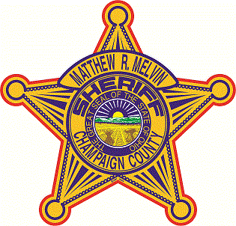](http://www.bing.com/images/search?q=Champaign+County+Sheriff's+logo&id=BEC6ECD242BE63CABFD6314834B3E40A891339C5&FORM=IQFRBA&adlt=strict#view=detail&id=BEC6ECD242BE63CABFD6314834B3E40A891339C5&selectedIndex=0)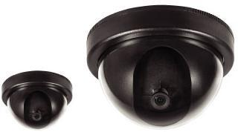

**S.C.E.N.E Camera Registry Program**

**The Champaign County Sheriff's Office wants you to join our crime fighting team by joining our S.C.E.N.E Camera Registry Program. The S.C.E.N.E. Program allows citizens and business owners to register the locations of their video surveillance systems/ wildlife cameras with the Sheriff's Office. When a crime occurs, the Sheriff's Office will be able to identify those locations of video surveillance or wild life camera systems faster and enlist the assistance of citizens to help us collect video or photography evidence.**

**Using the geographic locations of the registered cameras, the Sheriff's Office will be able to directly e-mail citizens in an area in which a crime occurred.**

**A common e-mail may ask the citizen to check their video surveillance system or wild life camera system for a specific date and time for video/ photography capturing a suspect, getaway car or a crime. If the citizen finds any video evidence, they can contact the Sheriff's S.C.E.N.E Program to make arrangements for video or photography retrieval.**

**Your Home security information will be kept confidential. This information will also be added to the Champaign County’s 911 Communication Center CAD System.**

**The S.C.E.N.E. Program allows citizens and business owners to register the locations of their video surveillance systems/ wildlife cameras with the Sheriff's Office. At** [**www.champaignohiosheriff.com**](http://www.champaignohiosheriff.com) **or if you have any questions please contact Captain David A. Rapp at (937) 484-1935. Email** [**drapp@co.champaign.oh.us**](mailto:drapp@co.champaign.oh.us)**.**

**Your Home security information will be kept confidential the information will also be added into the Champaign County’s 911 Communication Center CAD System.**

It is my duty to keep our citizens of our community safe.

*Sheriff Matthew R. Melvin*

***IF YOU CAN SEE THIS WE CAN SEE YOU***

**BENEFITS OF REGISTRY**

* Help Reduce Crime
* Make your home or business safer.
* Help solve crime

***Sheriff and Citizens Expanding Neighborhood Eyes***

**S.C.E.N.E.**

Citizens making a difference, addressing the needs of crime prevention within our Champaign County Communities.

### Champaign County Sheriff’s Office

308 Miami Street

Urbana, Ohio 43078

Phone: (937) 484-6091

Fax: (937) 484-6093

www.champaignohiosheriff.com